Seasonality in US Home Price Indices
In prior Collateral Analytics research, we have often stated that residential housing markets are not just seasonal in terms of the volume of listings and sales over the course of a year, but housing markets also exhibit seasonality with respect to price. This price seasonality tends to be more pronounced in markets where the average climate is colder, making home searches or moves less appealing over winter months. We also have noted that seasonality exists even in markets like Honolulu or San Diego where winter weather does not inhibit home search or moves. This is a result of several factors common to all US markets including school cycles, holiday patterns, and peak hiring cycles.
Recall how strong seasonality is in markets like Chicago, shown in Exhibit 1 below. We show that both time on the market and average home prices vary over the course of a year. One might speculate that some of this variation could be related to systematic differences in the sizes of homes selling over the course of a year, but we adjust for size and still get a pattern as shown in Exhibit 2, below.
Exhibit 1: Chicago Area Residential Prices and Selling Time Shown Monthly
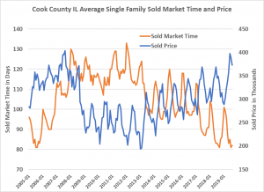

Exhibit 2: Chicago Average Historical Percentage Changes in Home Prices Over the Course of a Typical Year
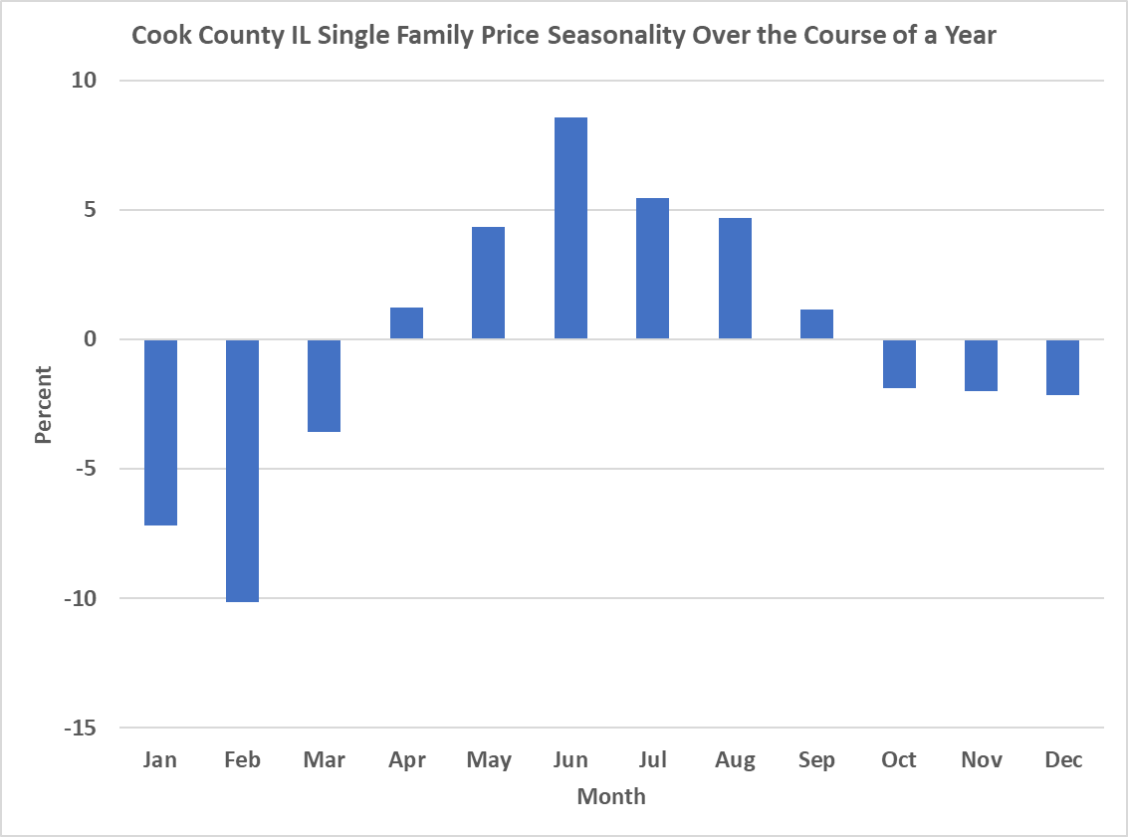
It is no surprise to see seasonality in home sales volumes over time in markets with significant variation in climate, but we have repeatedly noted that prices are also affected. For a buyer that can buy whenever they choose, the best time to buy is during the early part of the year. They may be able to save several percent in terms of the price paid versus the average price for similar homes. For sellers, it is generally best to sell in spring and summer and again, the result is an above average price by a significant amount as shown above. These patterns persist in all markets to some degree.
What is new is that we can now produce daily prices in full, or adjusted for size, and do this for all the markets in the US. Below in Exhibit 3, we show median residential prices for the major markets of the US, followed by the daily prices adjusted for size in Exhibit 4. Both patterns are similar and it may surprise some readers that we have clear seasonality in home prices across the US. For this reason, we report our changes in prices annually, as well as daily and monthly. The annual change eliminates the need to adjust for seasonality.

Exhibit 3: Single Family Residential Home Prices Calculated Daily from 2005 for both list and sold prices.
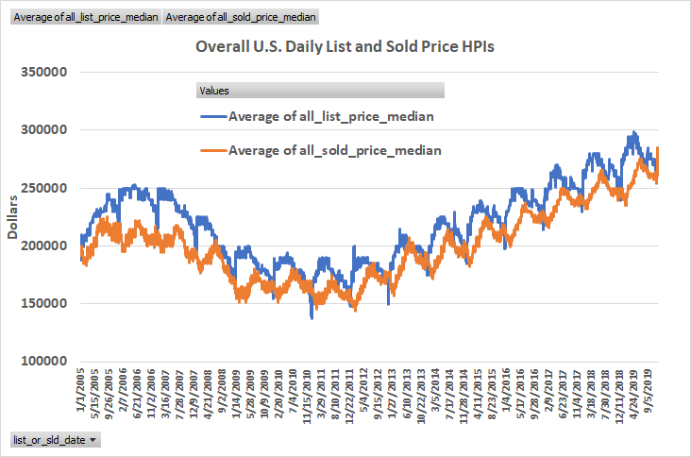
Exhibit 4: Single Family Residential Home Prices Calculated Daily from 2005 for both list and sold prices per square foot of living area.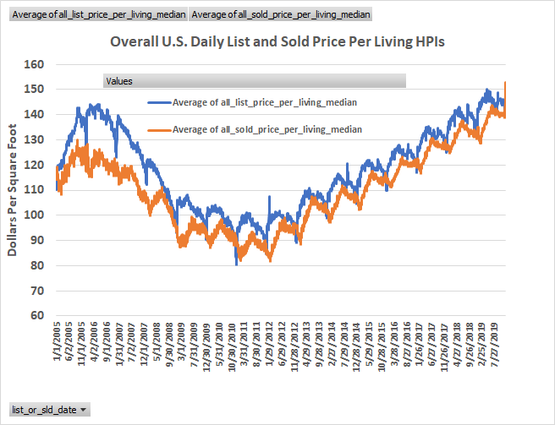
The variation from trough to peak price per square foot of living area for the nation as a whole has a band width of at least 12.5% on average. Stated another way, the average price for which the typical home sells can vary by as much as plus or minus 6.25% from the annual average.
At average prices for the nation as a whole approaching $280,000 (including condominiums and detached housing) such variation amounts to $17,500 that can be saved or earned, if the timing of the transactions can be chosen, with even higher figures for colder markets. The problem for most households is that they must sell a home, as well as buy a home, and this constraint allows persistence in these price variations over the course of each calendar year.
Conclusions
One would expect that with more informed markets, the variation observed in all the exhibits shown here would diminish, and that appraisers would spend more effort on adjusting sales prices for seasonality, but this does not appear to be the case. Perhaps the market is not aware of how much one can save by timing home buying?

References
Miller, N.G., V. Sah, M. Sklarz, and S. Pampulov “Is there Seasonality in Home Prices – Evidence from CBSAs”, Journal of Housing Research, Vol. 22, No. 1, pp 1-17, 2012.
Predicting How Long It Will Take To Sell A Home by Dr. Michael Sklarz* and Dr. Norman Miller** | September 12, 2019 available at https://www.collateralanalytics.com/blog/2019/09/12/predicting-how-long-it-will-take-to-sell-a-home/

