**Market Equilibrium Analysis**

Richard L. Parli, MAI

The Johns Hopkins University

Carey Business School

1625 Massachusetts Avenue, NW

Washington, DC 20036

Office Tel 703-273-6677

Norman G. Miller, Ph.D.

University of San Diego

Burnham-Moores Center for Real Estate

5998 Alcala Park

San Diego, CA. 92110-2492

Office Tel 619 260 7939

**Market Equilibrium Analysis**

**Abstract**

Extending the work of authors like Mueller, Pyhrr, Smith, Rosen and others on real estate cycles a definition of market equilibrium is explored. A new definition is offered identifying stable rental rates as the key indicator. Recent research on the application of the new definition is presented and a second definition - equilibrium vacancy - is proffered. Finally, possible applications for the new approach to market equilibrium analysis are presented.

Keywords: Equilibrium vacancy rate, predicting rents, long-term vacancy rates, natural vacancy, normal vacancy, vacancy and rent adjustments.

**MARKET EQUILIBRIUM ANALYSIS**

**Introduction**

"What's the vacancy rate?" That's often the first question a market analyst will ask about a particular market. The answer, of course, is expected to communicate the health of that market. Such is the power of the vacancy rate. To market analysts, a high vacancy rate is often considered bad; a low vacancy rate is often considered good. High and low, however, are relative terms and must be put into context. The context for a market vacancy rate is the equilibrium vacancy rate.

Vacant real estate space has often been viewed as a negative market characteristic. In fact, much of the market operates with the goal of eliminating vacant space, thereby matching demand with available supply. From the landlords' perspective, this may be a desirable goal. From the market's (and prospective tenant's) perspective, however, zero vacancy is a negative condition that prevents satisfying both tenant relocation and new demand. Given these underlying conditions , the question arises as to how much vacant space is needed in a balanced, efficient market?

Since disequilibrium is manifested by rising or falling rents, it stands to reason that a balanced, efficient market should be characterized by stable rents. Equilibrium is therefore characterized by stable rents. Since vacancy is recognized as the greates influence on rental rates, it follows that an equilibrium vacancy rate is that rate which produces no upward or downward pressure on rents. Comparing a market’s actual vacancy rate with its equilibrium vacancy rate can provide insights into a market's current condition as well as an indication of future rent movements.

The purpose of this paper is to: 1) explore the concept of market equilibrium by tracing its evolution; 2) present a new definition for market equilibrium and equilibrium vacancy rate; and, 3) offer possible applications of the new approach to market equilibrium.

**Market Equilibrium as Defined in the Literature**

Considering its importance to real estate market analysis and valuation, the specific concept of market equilibrium is given relatively little attention in the literature. Typically, the concept is treated as if the meaning were self-evident (Hagen and Hansen, 2010). Often, the concept of disequilibrium is addressed (Voith & Crone 1988, Clapp 1993). In any event, when addressed, it is identified as simply the point where demand and supply are equal. For example, the most recent edition of The Appraisal of Real Estate (14th ed., 2013)) defines market equilibrium as follows:

The theoretical balance where demand and supply for a property, good, or service are equal. Over the long run, most markets move toward equilibrium, but a balance is seldom achieved for any period of time.[1]

This is also the definition in the 5th edition of *The Dictionary of Real Estate Appraisal* (2010) and referenced by Jorgensen and Fanning (2013).[2] However, if reading this definition in the literal sense, one might conclude that market equilibrium is only achieved at 100% occupancy. This unreasonable implication was tempered with the 6th edition of *The Dictionary of Real Estate Appraisal* (2013) which modified the definition to include vacant space:

The theoretical balance where demand and supply for a property, good, or service are equal *with the* *only vacant space* *being space needed to service the market friction of normal tenant movements and space needed to accommodate new demand coming into the market.* Over the long run, most markets move toward equilibrium, but a balance is seldom achieved for any period of time.[3] (emphasis added)

While continuing to assert that the concept is "theoretical", it is nonetheless encouraging that the new definition includes an allowance for vacant space".[4] According to the definition, the vacant space associated with market equilibrium is allocated between the "space needed to service the market friction of normal tenant movements" and "space needed to accommodate new demand coming into the market." We will address each qualifier separately.

The space needed to service market friction is generally referred to as *frictional vacancy*. The theory of frictional vacancy may first have been identified by Hauser & Jaffe (1947) when they observed that the “continuous turnover in housing occupancy necessitates a minimum number of vacant units which may be described as frictionally vacant units.”[5] Hauser & Jaffe, who had built upon the work of Homer Hoyt (1933), were concerned with a housing shortage following World War II. The presence of frictional vacancy has been accepted by analysts as being a necessary ingredient to an efficient market. Aside from this recognition, there is little

known about this vacancy - it cannot be measured and therefore cannot be proven to exist. It is simply a theoretical construct that justifies a certain level of vacant space as present in every real estate market and implies that an efficient market is always going to have an excess of supply over demand (i.e., a certain degree of inefficiency).

The space needed to accommodate new demand has been referred to as *lag vacancy* (Fanning, 2014). This relatively recent theory states that the market needs an "inventory reserve for forecasted new growth."[6] This component of equilibrium is based on the demand characteristics of a market - the greater the anticipated demand, the greater the required future supply, and the greater the current equilibrium vacancy rate. Fanning demonstrates that when all else is equal, a high growth market will have a higher equilibrium vacancy rate (lower equilibrium occupancy rate). Regardless of a market's growth rate, if future supply increases match demand ( after allowing for frictional vacancy), a vacancy rate that considers near-term future demand and supply will represent market equilibrium. Sample calculations are shown in table 1:[7]

**Table 1 High Growth/Low Growth Sample Calculations**

Interestingly, this approach rests on the initial theory that a 5% frictional vacancy rate exists in the market, and that this 5% vacancy rate is the true current equilibrium vacancy rate. With no forecasted new demand, the market equilibrium vacancy rate would be 5%. This is shown in Table 2:

**Table 2 No Growth Market Calculations**



The fallacy is not with the formula, which correctly relates future demand to future supply. The fallacy is with the theory that frictional vacancy is the basis for calculating equilibrium vacancy.

We present the following alternative definition of real estate market equilibrium:

The balance of space where supply of a property type exceeds demand by an amount of space that produces stable rents.

or simply:

The relationship of demand and supply that results in real rent stability.[8]

This definition moves the concept of market equilibrium from a theoretical condition to one with practical applications.

**Linking Equilibrium to Rents**

There is an abundance of published research linking vacancy to equilibrium and equilibrium to rents. Possibly the first to connect the three was Smith (1974) concluding that there is some level of vacancy that is associated with market equilibrium, “at which rents are in equilibrium”.[9]

Smith’s later collaboration with Rosen (1983) postulated that a real estate market in equilibrium means a vacancy rate at which rent changes equal zero.[10] Numerous subsequent studies expressed the same conclusion but in different ways: that rate of vacancy that provides landlords with no incentive to adjust rents (Jud & Frew 1990), (Mueller 1999) and others; the vacancy rate where effective demand is equal to effective supply (Clapp 1993); a market is in equilibrium when there is no tendency toward changes in prices or quantities (McDonald & McMillen 2011).

Classical economic theory supports the premise that if there is market disequilibrium due to excess supply, there will be downward pressure on rental rates, which produces new effective demand for the vacant space.[11] If the disequilibrium is due to excess demand, there will be upward pressure on rental rates until the relative demand is diminished (via higher rents or additional delivered space). Consistent with this theory, there must be some level of vacancy - equilibrium vacancy - that is associated with no upward or downward pressure on real rents.

The equilibrium vacancy rate hypothesis is, therefore, that there must be a market vacancy rate where demand and supply are *effectively* equalized. As a corollary, the movement of rents in a market is inversely related to the vacancy rate of that market and movement away from equilibrium can produce either upward or downward pressure on rental rates.

**Identification of the Equilibrium Vacancy Rate**

There is no known way to forecast an equilibrium vacancy rate; it must be inferred or extracted from the historical record. Over the years, research has produced at least 16 published studies that estimated the equilibrium vacancy rate for different property types in many different communities and for many different time periods. The published research has emphasized two main methods (1) regression analysis using rent as a dependent variable; and (2) simply using the average vacancy rate over an extended time period. The results range from 4.4% to 22.3%. All have relied upon historical vacancy rates linked to published rental rates.

Parli and Miller (2014) tested and compared the results of these methods in nine markets of study: three cities on the west coast, three cities on the east coast, and three cities in the central United States. In all cases, the equilibrium vacancy rate of the city’s Class A office space was the focus of analysis.[12] Their conclusion is that consistent reliance on the mean vacancy rate would produce a reliable indication of a market's equilibrium vacancy rate. In addition, the equilibrium vacancy rate indicators for each city demonstrate enough difference that variation is confirmed; localized analysis is essential. Geltner, Miller, et al (2007) concluded that the regression process may not produce reliable results unless net effective rent is used, stating that “real [net effective] rents reflect the actual physical balance between supply and demand in the space market.”[13] By using the mean vacancy rate, this problem is eliminated.

A major value of relying on the long run mean vacancy rate is that it implicitly recognizes the cyclical nature of any real estate market and is consistent with the *Rental Growth Theory*.[14] This theory states that the long run average occupancy rate is the point of inflection, where the growth rate of real rents change course. In the process of changing course, the rents inhabit (however briefly) an area of stability. Since our definition of equilibrium is based not on growth rates, but a change in direction of rents, this temporary stability signifies market equilibrium.

The long run average (or *natural*) vacancy rate can be a reliable indicator of the equilibrium rate for any given market, as long as adequate fluctuation over an extended period has been experienced by the market. Mueller (1999) observed that the market cycle was not symmetrical and that the response of rents was different if the market was above or below the long term average vacancy. This suggests that while the historic mean vacancy rate can be calculated, forecasting rents may require an adjustment for current supply and demand characteristics. For example, if the mean is calculated at a time of peak occupancy (or vacancy), this could skew the average upward (or downward) and result in an equilibrium vacancy rate that maybe artificially high (or low).[15] This result is implied by the Fanning use of lag vacancy - a market that is forecast to grow faster may have an artificially high vacancy rate if future delivery is taken into account. It is understood that a market in equilibrium will remain in equilibrium as long as the growth in supply matches the growth in demand (both in rate and timing). A mismatch will, of course, move the market out of equilibrium because the market's actual vacancy rate will diverge from its equilibrium vacancy rate.

Mueller (1999) correctly indicated that rental growth will be below inflation when the actual vacancy rate for a market is above the long term average vacancy rate. Of course, the inverse is also true. Thus, in a stable market in equilibrium, the change in rent should be consistent with the change in inflation.[16] As an extension of this theory, it can be seen that new construction will not take place unless rental rate change exceeds building cost inflation to the extent that market rents are equal to or exceed new construction rent (i.e., feasibility rent).

While we know that the vacancy rate plays a significant role in rent changes, this role may become more prominent as the vacancy rate distances itself from the equilibrium level. The research could be skewed in this direction since the further away from equilibrium the vacancy rate gets, the less likely concessions are to mask changes in face rent.

It is of interest that virtually all of the indicators of equilibrium vacancy rate exceed 5%, the industry standard for frictional vacancy. In this context, if market demand drives vacancy rates to as low as 5%, that market is likely experiencing strong upward pressure on rents - a characteristic in conflict with market equilibrium.

Most research does not distinguish between frictional vacancy and equilibrium (natural) vacancy (e.g., Clapp 1993, Sivitanides (1997), Krainer 2001, Thoma 2005). In fact, most recent articles do not even acknowledge the existence of frictional vacancy. A main reason for this may be not the denial of its presence, but it has little use in contemporary markets. The original utility of frictional vacancy was to calculate the amount of space that excess supply could support.[17] Although the growth in certain cities has been robust over the past fifty years, it is nonetheless unusual for aggregate demand to actually exceed aggregate supply. Consequently, market analysts rarely need to calculate the amount of supply that excess demand can support. The challenge is to determine the deficiency of aggregate demand relative to aggregate supply, recognizing that a certain amount of vacant space is necessary to accommodate market dynamics.

The (theoretical) relationship of frictional vacancy and equilibrium vacancy to market vacancy is demonstrated in Exhibit 1.

**Exhibit 1. Relationship of Equilibrium Vacancy to Frictional and Overall Vacancy Rates**

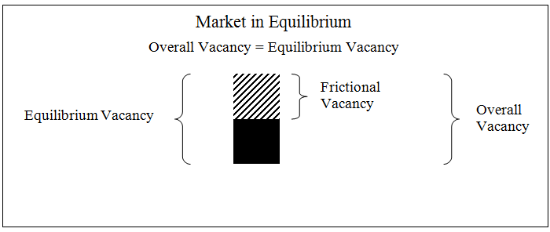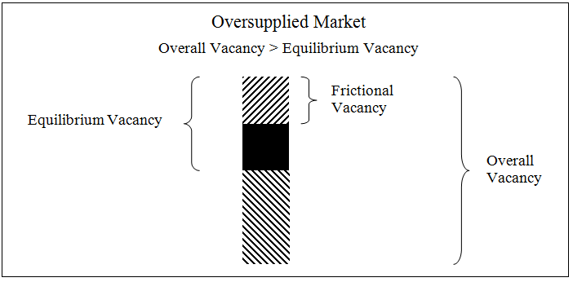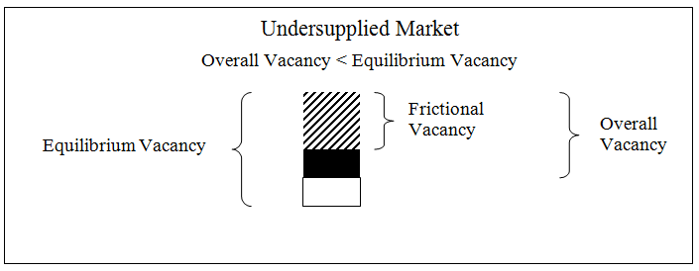

**Equilibrium Vacancy Rate Applications**

Now that it has been shown that the simple average of a market's long term vacancy rate can be a reliable indication of that market's equilibrium vacancy rate, of what value is this knowledge to the market analyst?

* Knowing the distance that current vacancy is from equilibrium vacancy The expected direction of vacancy movement would be indispensible to developing a reliable cash flow model on a property. Rental rates should not change direction until the market passes through equilibrium.
* Knowing the slope of the change in rental rates is also important. This can be inferred from the slope of previous changes that occurred under similar circumstances. Segmenting a change and regressing the data can provide the slope of the change, and projecting growth/decline in future rents.
* There is good reason to associate equilibrium vacancy with development feasibility. That is, until rents are ascending, development plans will naturally be postponed; rents will not ascend until vacancy has dropped below equilibrium level. The commitment to develop is based on many factors other than the movements of rent, but financial feasibility is a major consideration. McDonald (2000) described the equilibrium vacancy rate as "being consistent with a net rent that provides no incentive to change the size of the stock of space."[18]

All three of these items are identified by Mueller (1999), and shown in Exhibit 2.[19]

**Exhibit 2. Long Term Vacancy and Market Cycles**

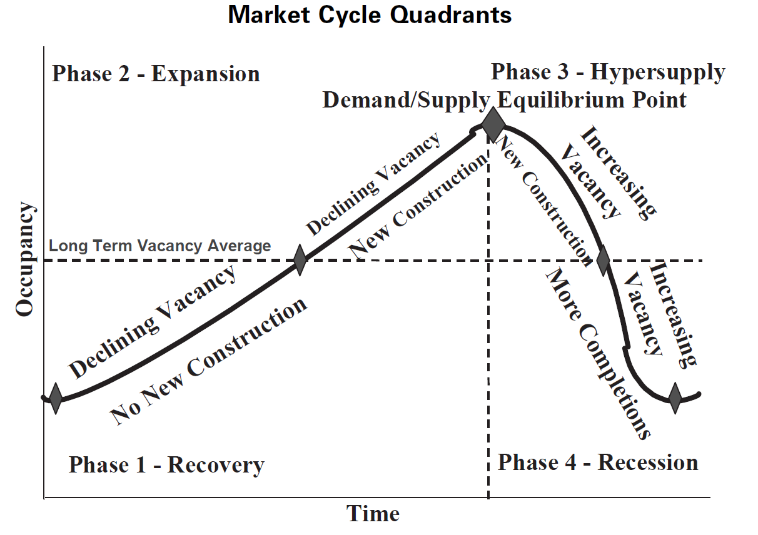

In describing real estate cycles, Mueller focuses on demand and supply growth rates and defines *demand/supply equilibrium* as being when "demand and supply growth rates are equal (dg = sg) at the peak and trough of the market cycle (thus existing space plus new construction exactly matches new demand)." Mueller indicates agreement with Pyhrr, Webb and Born (1990) in stating "the only real demand/supply equilibrium point is at the peak of the real estate cycle where supply growth finally catches up to demand growth." Mueller clarifies this equilibrium condition in the real estate cycle as being the peak point, stating that at the peak "the space market is usually at its tightest level (occupancy rates highest) and the rental growth rate should also be at its highest level." Yet, Pyhrr, Webb and Born, indicated that "equilibrium occurs in this apartment market when occupancy rates are in the range of 92 - 96 percent."[20] We interpret this to mean that the peak of the market is when actual vacancy meets frictional vacancy, producing hyper-supply. As such, the "demand/supply equilibrium" identified in Exhibit 2 should not be confused with a market equilibrium as defined in this article; our position is that market equilibrium is actually represented by *Long Term Average Occupancy* shown in Exhibit 2.[21]

One final observation: it appears that equilibrium vacancy rates tend to be lower for residential properties and higher for office properties. We uncovered no direct research comparing the equilibrium vacancy rates, although there is anecdotal evidence to support this conclusion. For example, Hagen and Hansen (2010) concluded that for the Seattle and surrounding King County market, the equilibrium vacancy rate for residential rental properties was between 4.97% and 5.25%.[22] This is quite low in comparison with the results of Parli and Miller (2014) for Seattle Class A office space of about 10%.[23] We expect that this relationship is similar in kind throughout the nation, if not in degree. One reason for such differences can be explained by market friction. Residential has lower friction with less lumpy demand than office. There are also structural differences - residential growth may be more predictable since it is a function of household growth rates which seldom move radically while job growth may change faster, thus needing more space in equilibrium for the office market to handle the more volatile demand characteristics.

**Conclusions**

Research reviewed in this paper is convincing that vacancy influences rental rates. Market observation, however, indicates that rental rates also influence vacancy. At a fundamental level, both rents and vacancy are responsive to economic demand for space relative to supply. Demand absorbs vacant space to the point that rents are driven up, which stimulates new construction, which may drive average rents up (due to the premium charged for new space) or down (due to an oversupply). This cyclical pattern produces variations in vacancy rates that tend toward a central point, known as the market's natural vacancy rate. The analysis in this article reveals that the natural vacancy rate is a reliable indicator of the market's equilibrium vacancy rate, and a type of market trigger that can be used to forecast changes in future rental rates.

Given that vacancy can and does significantly influence rent changes, and that stable rents are a characteristic of market equilibrium, it follows that there must be some level of vacancy - the equilibrium vacancy rate - which produces stable rents. Vacancy in excess of this rate will produce downward pressure on rents; vacancy of less than this rate will produce upward pressure on rents. Although we agree that inflationary/deflationary pressure on rents can cause market-wide movement, this issue and others are avoided by relying on the mean vacancy rate for an indication of the market’s equilibrium rate. In doing so, however, one must recognize the limitations of using the historical mean vacancy rate given that the equilibrium rate is likely dynamic and asymmetrical. It is dynamic in that it is a moving target, shifting with each new vacancy rate. It is asymmetrical in that, even though it is an extension of the theory of real estate cycles, rents would be expected to respond differently to changes in vacancy depending on the relative relationship to the equilibrium rate.

The equilibrium vacancy rate hypothesis is not in conflict with the presence of frictional vacancy. Accepting frictional vacancy as a necessary component only allocates the numbers and does not change the relationship. For example, if frictional vacancy for a given office market is assumed to be 5%, then the equilibrium vacancy rate almost certainly exceeds this amount. Because search, contracting, and moving costs cause some vacancy in every market, a portion of the vacancy of the equilibrium condition is most certainly associated with friction.

Knowledge of equilibrium vacancy is a valuable component of market analysis and valuation. It can be used to forecast when a change in vacancy will actually produce a change in rent, something critical to any cash flow prediction. We have demonstrated that just because the vacancy rate is moving does not mean rental rates will move. Instead, movement in rents is altered when the vacancy rate crosses the critically important equilibrium rate, and this rate may in fact be a range, and vary by property types and local market.

**REFERENCES**

Amy K., Ming Y. S., Yuan L. L. (2000) The natural vacancy rate of the Singapore office market, Journal of Property Research, 2000, Vol. 17, No, 4, pp. 329–338.

Anari, M.A. & Hunt, Harold D., *Natural Vacancy Rates in Major Texas Office Markets,* Technical Report, Real Estate Center, November 2002.

Blank, David M. & Winnick, Lois, “The Structure of the Housing Market,” *Quarterly Journal of Economics*, May 1953, 67, pp. 181 – 203.

Born, Waldo L. & Pyhrr, Stephen A. "Real Estate Valuation: The Effect of Market and Property Cycles", *Journal of Real Estate Research*, Vol 9: No. 4, 1994, pp. 455-485

Carn, Neil, Joseph Rabianski, Ronald Racster, and Maury Seldin, *Real Estate Market Analysis, Techniques and Applications,* Prentice Hall, 1988.

Clapp, John M., *Handbook for Real Estate Market Analysis,* Prentice-Hall, Inc., 1987.

Clapp, John M., *Dynamics of Office Markets,* The Urban Institute Press, 1993.

Crone, Theodore M., “Office Vacancy Rates: How Should We Interpret Them?”, *Business Review*, Federal Reserve Bank of Philadelphia, May/June 1989.

Downs, Anthony, ”Cycles in Office Space Markets,” *The Office Building From Concept to Investment Reality,* Counselors of Real Estate, et al., 1993, pp. 153 – 169.

Eubank, Arthur A., Jr. & Sirmans, C.F., “The Price Adjustment Mechanism for Rental Housing in the United States” *Quarterly Journal of Economics,* February, 1979, pp. 163 – 168.

Fanning, Stephen F., *Market Analysis for Real Estate*, Appraisal Institute, 2nd ed., 2104.

Fanning, Stephen F., *Market Analysis for Real Estate*, Appraisal Institute, 2005.

Fanning, Stephen F., MAI, Grissom, Terry V., MAI, PhD, Pearson, Thomas D., MAI, PhD., *Market Analysis for Valuation Appraisals,* Appraisal Institute, 1994.

Friedman, Milton, “The Role of Monetary Policy, *The American Economic Review*, Volume LVIII, Number 1, March 1968, pp. 1-17.

Gabriel, Stuart A. & Nothaft, Frank E., “Rental Housing Markets and the Natural Vacancy Rate”*, AREUEA Journal*, Vol 16, No. 4, 1988, pp. 419 – 429.

Geltner, David M., Miller, Norman G., Clayton, Jim, Eichholtz, Piet, *Commercial Real Estate Analysis & Investments*, Thomson South-Western, 2007.

Hagen, Daniel A. & Hansen, Julia L, “Rental Housing and the Natural Vacancy Rate,” *Journal of Real Estate Research*, Vol. 32, No 4, 2010, pp. 413 - 433.

Hauser, P.M. & Jaffe, A.M., “The Extent of the Housing Shortage,” *Law and Contemporary Problems*, Winter 1947, Vol. 12, Issue 1, pp. 3 - 15.

Hoyt, Homer, *100 Years of Land Values in Chicago: The Relationship of the Growth of Chicago to the Rise in its Land Values*, 1830–1933, Chicago, IL: University of Chicago Press, 1933.

Jorgensen, Kerry M. & Fanning, Stephen F., "One Step Further - Implementing the Recommendations of Guide Note 12", *The Appraisal Journal*, Summer, 2013.

Jud, G. Donald & Frew, James, “Atypicality and the Natural Vacancy Rate Hypothesis”, *AREUEA Journal*, Vol 18, No. 3, 1990, pp. 294 – 301.

Krainer, John, *“*Natural Vacancy Rates in Commercial Real Estate” *FRBSF Economic Letter,* Federal Reserve Bank of San Francisco, No. 2001-27, October 5, 2001.

McDonald, John F., “Rent, Vacancy and Equilibrium in Real Estate Markets", *Journal of Real Estate Practice and Education,* Volume 3, Number 1, 2000, pp. 55 – 69.

McDonald, John F. & McMillen, Daniel P. *Urban Economics and Real Estate*, John Wiley & Sons, 2nd ed., 2011

Miller, Norm G. “Downsizing and Workplace Trends in the Office Market” *Real Estate Issues*, CRE, Vol. 38, No. 3, 2013.

Mueller, Glenn R., "Understanding Real Estate’s Physical and Financial Market Cycles," Real Estate Finance, 1995, 12:1, 47–52.

Mueller, Glenn R., “Real Estate Rental Growth Rates at Different Points in the Physical Market Cycle” *Journal of Real Estate Research*, Vol 18: No. 1, 1999, pp. 131-150

Parli, R.L. and N.G. Miller “Revisiting the Derivation of an Equilibrium Vacancy Rate”, *Journal of Real Estate Portfolio Management*, Vol 20, No. 3, 2014, pp. 195-208

Pyhrr, S. A., J. R. Webb and W. L. Born, "Analyzing Real Estate Asset Performance During Periods of Market Disequilibrium Under Cyclical Economic Conditions: A Framework for Analysis", *Research in Real Estate*, Vol. 3, 1990, JAI Press.

Pyhrr, S. A., S.E. Roulac, and W. L. Born, "Real Estate Cycles and Their Strategic Implications for Investors and Portfolio Managers in the Global Economy" *Journal of Real Estate Research*, Vol. 18, No. 1, 1999, pp.7 – 68.

Rabianski, Joseph F., “Vacancy in Market Analysis and Valuation”, *The Appraisal Journal*, April 2002, pp. 191 – 199.

Rosen, Kenneth T. & Smith, Lawrence B., “The Price-Adjustment Process for Rental Housing and the Natural Vacancy Rate,” *The American Economic Review,* Vol. 73, No. 4, September 1983, pp. 779 – 786.

Shilling, James D., Sirmans, C.F. & Corgel, John B., “Price Adjustment Process for Rental Office Space”, *Journal of Urban Economics,* Vol. 22 (1), 1987, pp. 90 – 100.

Sivitanides, Petros S., “The Rent Adjustment Process and the Structural Vacancy Rate in the Commercial Real Estate Market”, *Journal of Real Estate Research*, Vol. 13, No. 2, 1997, pp.195 – 209.

Smith, Lawrence B., “A Note on the Price Adjustment Mechanism for Rental Housing”, *American Economic Review,* Vol. 64, No. 3, 1974, pp. 478 - 481

Thoma, Mark, “The Natural Vacancy Rate for Housing,” *Economist’s View*, blog, November 29, 2005.

Sumichrast, Michael “Housing Market Analyses,” as reprinted in *Readings in Market Research for Real Estate*, edited by James Vernor, Appraisal Institute, 1985, p. 69.

Voith, Richard & Crone, Theodore, “National Vacancy Rates and the Persistence of Shocks in the U.S. Office Markets”*, AREUEA Journal*, Vol 16, No. 4, 1988, pp. 437 – 458.

Wheaton, William C. & Torto, Raymond G. “Vacancy Rates and the Future of Office Rents”*, AREUEA Journal*, Vol 16, No. 4, 1988, pp. 430 – 436.

1. The Appraisal of Real Estate, Appraisal Institute, 14th ed., 2013, p. 306.
2. Jorgensen, Kerry M. & Fanning, Stephen F., "One Step Further - Implementing the Recommendations of Guide Note 12", *The Appraisal Journal*, Summer, 2013, p. 215.
3. Dictionary of Real Estate Appraisal, Appraisal Institute, 6th ed., p. 139.
4. We find it troublesome that the definition also relates a "good, or service" as needing vacant space.
5. Hauser, P.M. & Jaffe, A.J., “The Extent of the Housing Shortage”, Law & Contemporary Problems; Winter1947, Vol. 12, Issue 1, p. 3.
6. Fanning, Stephen F., Market Analysis for Real Estate*,* Appraisal Institute, 2nd Ed., 2014, p. 198.
7. These calculations replicate those by Fanning, 2014, p. 199.
8. Real rents would be stable even though they move nominally with inflation; In a market with 1.5% inflation per year the rents would rise by approximately 1.5% per year.
9. Smith, Lawrence B., “A note on the Price Adjustment Mechanism for Rental Housing”, *The American Economic Review*, June 1974, p. 481.
10. Rosen, Kenneth T. and Smith, Lawrence B., “The Price Adjustment Process for Rental Housing and the Natural Vacancy Rate”, *The American Economic Review*, September 2983, pp. 779 – 786.
11. Since demand consists of not only desire but also affordability - the ability to act on the desire.
12. Parli, Richard L. & Miller, Norman G. "Revisiting the Derivation of an Equilibrium Vacancy Rate," *Journal of Real Estate Portfolio Management*, Vol. 20, Issue 3, 2014.
13. Geltner, David M., Miller, Norman G., Clayton, Jim, Eichholtz, Piet, Commercial Real Estate Analysis & Investments, Thomson South-Western, 2007, p. 106.
14. Mueller, Glenn R., “Real Estate Rental Growth Rates in Physical Market Cycle”, *Journal of Real Estate Research*," Volume 18, Number 1, 1999, p. 135.
15. This problem could be eliminated by matching the study period to a full real estate cycle(s).
16. Mueller, Glenn R., "Real Estate Rental Growth Rates at Different Points in the Physical Market Cycle", *Journal of Real Estate Research,* Vol. 18, No. 1, 1999, p. 135.
17. See for instance, Hauser & Jaffe, "The Extent of the Housing Shortage," *Law and Contemporary Problems,* Winter 1947, Vol. 12, Issue 1, pp. 3 - 15.
18. McDonald, John F., “Rent, Vacancy and Equilibrium in Real Estate Markets," *Journal of Real Estate Practice and Education,* Vol. 3, No. 1, 2000, p. 59.
19. Mueller, Glenn R., "Real Estate Rental Growth Rates at Different Points in the Physical Market Cycle", *Journal of Real Estate Research,* Vol. 18, No. 1, 1999.
20. Pyhrr, Stephen A., Webb, James R. and Born, Waldo L., "Analyzing Real Estate Asset Performance During Periods of Market Disequilibrium under Cyclical Economic Conditions," *Research in Real Estate,* Vol. 3, 1990, p. 84, p. 465.
21. Exhibit 2 also shows construction as being triggered/dampened by the cycles' relationship to the LTAO. We agree, but testing this theory would be problematic due to the small sample size typically associated with most markets.
22. The Hagen and Hansen study included apartment projects of 20 or more units over 35 biannual periods, beginning in September 1988 and ending in September 2005.
23. The Parli and Miller study covered only Class A office space within City of Seattle over 56 quarters beginning January 2000 and ending December 2013.