Does Green Still Pay Off?
September 24, 2010

By Norm Miller*, PhD, Andrew Florance** and Jay Spivey**
*V.P. Analytics, Costar Group
** CEO and President, CoStar Group
*** Sr., Director Research and Analysis, CoStar Group

In one of the earlier office property studies authored with Andy Florance and Jay Spivey entitled “Does Green Pay Off?” comparing green buildings, defined as either Energy Star labeled or LEED certified at any level, published in the Journal of Real Estate Portfolio Management, Vol.14, No.4, Oct-Dec. 2008 we found strong evidence of both significant rental premiums but also faster absorption and lower cap rates/higher prices per square foot. Since that date we have noted a flurry of buildings planned in the 2004 to 2006 period but delivered 2007 through the present which have become LEED certified. Much of the Class A construction for new office buildings has been aimed at becoming LEED certified and in some markets, like San Francisco, it is a requirement. The timing could not have been worse for those coming on line in more recent year and we have seen this have an impact on the latest statistics making apples to apples comparisons more challenging. (See Exhibit 1 year to date chart.) Our findings at the time suggested significant rental premiums and significant sales prices premiums. Here is an update.

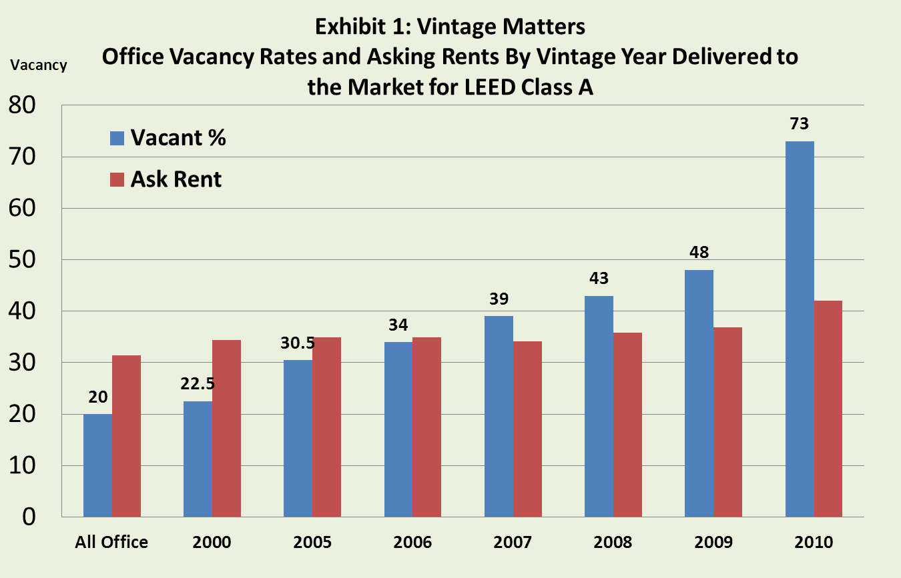

Costs which run nothing extra for an experienced team of designers and contractors to hit silver or better were easily surpassed by the value impact in our 2008 study. Investors and developers knew this to be true, even if appraisers lacking sufficient local comps would not verify the value premiums. In some cases and some local markets rents were not always higher as tenants were unwilling to pay more for a more efficient building and this resulted in an increasing proportion of full service or gross leased buildings so that landlords could reap the benefits of energy or water saving investments. In other cases tenants were required to lease in the equivalent of a LEED certified building (i.e. Federal agencies or California State government offices) or wished to lease green buildings as part of their CSR (Corporate Social Responsibility) policies and we observed significant rental premiums. Since then we have observed a growing interest in green leases and provisions by which energy savings benefit both the landlord and the tenant, but cynics remain and beyond the savings in energy or other resources, the ultimate market tests will be borne out through the impact on tenants via less sick time or higher productivity and retention of employees. For we now understand that the human costs are much greater than the operating costs and any significant impact on tenant productivity swamps energy or water savings. In this regard a few studies have started to shed some light on the probability of greater productivity. In “Green Buildings and Productivity” by Dave Pogue and myself published in the Journal of Sustainable Real Estate, 2009, see www.JOSRE.org we found that many tenants experienced less sick time and greater productivity. At the same time it is clearly possible to well manage a non-green building or miss manage a green building and more study remains before green features than pay off become mainstream. Rent premiums do vary by market. See Exhibit 2.

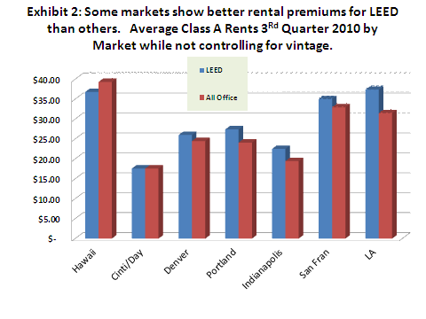

Overall we continue to see rent premiums based on national average rents, however, once again, local markets will vary. See Exhibit 3 below which is a survey of asking rents based on CoStar data.

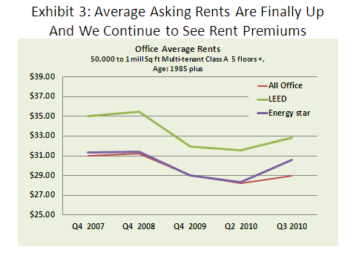

Vacancy rates also vary by market and most markets showing higher vacancies are subject to the vintage problem noted above. Still the vacancy rates on LEED properties were much worse in 2009 and we have seen a significant advantage in terms of absorption over the last year so that vacancy rates have nearly evened out in many cities which had significant new LEED designated office deliveries in the past 3 years. See Exhibit 4 below.

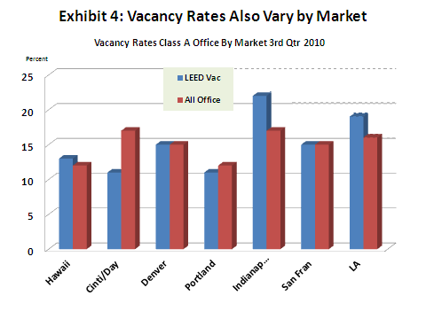
One constraint on the greening of existing buildings or investment in better quality buildings are the lack of understanding by most appraisers and the lack the training to understand how to value green features such as more efficient cooling systems and better air flow and gray water recapture systems. Someday this will change, but until then we hope that CoStar data, already used in a number of academic studies can be mined to understand the realities of the market.

We do not provide an update chart here on prices but we still continue to observe about a 40 basis point lower cap rate on similar LEED buildings when compared to non LEED Class A office sales. Again, the lack of sales data does make it necessary for appraisers to focus more on the energy savings from investments in water or energy conservation equipment or to examine the benefits of better air and light on productivity which will lessen economic obsolescence and increase rents relative to lower quality buildings. One new resource aimed at helping appraisers and lenders understand the impact of green features is found at http://www.greenbuildingfc.com/ titled “Value Beyond Cost Savings” by Scott R. Muldavin, 2010.

What we are observing now is a ramping up of existing building conversions and only through the EBOM (Existing Building Operations and Maintenance) program will we see a very rapid green conversion of the outstanding stock of buildings. Office continues to lead all other property types in this effort but warehouses have come on strong in adopting greener roofs (i.e. more sky lights, solar cells and or reflective surfaces), more self-generation of power and more efficient use of energy and water. There are green retail properties but the decision to go green is pretty much tenant driven and not landlord driven. In multifamily we have seen a slow take up of better lighting, solar tubes and a slow embracing of LEED scorecards but still we have seen some increased use of more efficient lighting and insulation and water recapture systems.

In the long run these greener buildings are likely to retain more vale as the bar is raised and tenant expectations change. Most of the green building owners plan on keeping their properties long term. They know that in the long run this modest effort in sustainable features pays off very well indeed even if they decide not to go for LEED certification. Those who have ignored many of the simple actions necessary to improve existing buildings when undergoing a retrofit, and this includes distressed property, or to design buildings for greater occupant comfort and operating efficiency will find not a value premium for green but a discount for brown.

One strategy that has not always worked for developers is to buy an inferior location at a reduced price and then presume that becoming LEED certified or Silver or Gold will more than compensate for an inferior site. It does not, except in those markets where tenants (i.e. California GSA) are required by law to go green and there is an insufficient supply. So going green is neither a panacea for all problems nor a solution for other site or building deficiencies.

We end with two Exhibits that show the building stock that is Energy Star or Leed as a proportion of the total stock. By far the greenest geography is Washington DC where nearly all new office buildings since 2007 are LEED certified. Yet, even in Washington DC the vast majority of commercial buildings are not very sustainable and there remains a huge opportunity to invest in this transition towards more productive and more energy and water efficient buildings.

Exhibit 5: Top 10 Greenest States/Region based on the proportion of green office buildings relative to the total stock of buildings in the market.

 | Greenest State
1 | DC
2 | OR
3 | VT
4 | WA
5 | CO
6 | MA
7 | ME
8 | NH
9 | IL
10 | CA
Source: CoStar data and the USGBC

Exhibit 6: Top 10 Brownest States/Region based on the proportion of green office buildings relative to the total stock of buildings in the market.
1 | OK
2 | LA
3 | WV
4 | SD
5 | MS
6 | ND
7 | AL
8 | KY
9 | IN
10 | NE
Source: CoStar data and the USGBC

LEED stands for Leadership in Energy and Environmental Design and is awarded by the USGBC at the certified, silver, gold, and platinum levels.

